

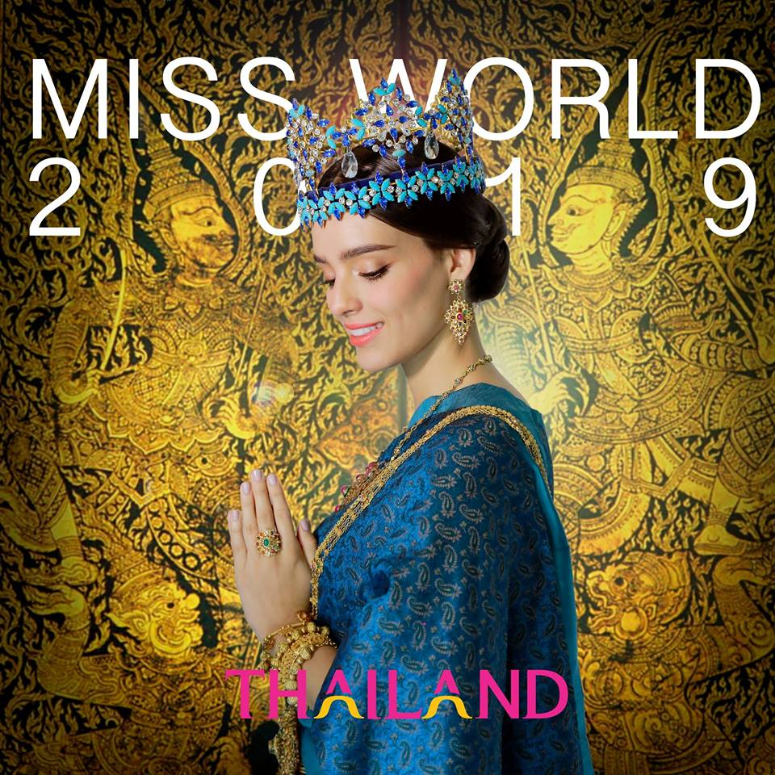

**Thailand officially confirmed as host for 69th Miss World Final in 2019**

(Bangkok, 18 February 2019) **The Miss World Organisation**, led by **Julia Morley, CEO and Chairman** has today announced the 69th Miss World Final will be hosted in Thailand. This is the first time in the history of Miss World that the month-long festival and final will take place in Thailand.

During the press conference held at Phaya Thai Palace in Bangkok, Julia Morley said: “I am delighted to have been invited to hold the 2019 Miss World Final in Thailand. Given the country’s rich culture and hospitality, the ‘Land of Smiles’ is the perfect place to welcome the 130 Miss World Nations”.

Started in 1951, Miss World has inspired and empowered thousands of young women to use their talents to support the poor, sick and disadvantaged through its ‘Beauty With A Purpose’ charitable programme. The longest-running international pageant, Miss World is not a traditional beauty pageant, but rather a platform for women from across the globe to raise awareness and funds in aid of humanitarian causes. The organisation prides itself on its philanthropic focus with millions of dollars being raised for good causes every year.

Delegates from 130 countries are scheduled to arrive in Thailand in November with the final to be held in December. During their month in Thailand they will participate in a string of preliminary activities and visit the most spectacular tourism sites across the country as well as take part in ‘Beauty With a Purpose’ fundraising activities to help good causes in Thailand.

Last year’s event was held in China, with the final in Sanya. This was the ninth time Miss World has been in China and has been credited with increasing global inbound tourism and boosting the local economy. China has two Miss World’s, Zhang Zilin was crowned in 2007 and Yu Wenxia in 2012.

The highly-anticipated Miss World final show will be telecast globally to over 100 countries, where viewers will watch as the reigning Miss World, Vanessa Ponce de León, who was crowned in China, pass the crown to the 69th Miss World in Thailand. Local organiser TW Pageants has been appointed to be the hosting partner for Miss World 2019 Final.

**Tanawat Wansom, Chief Executive Officer of TW Pageants**, said: “Following China, I am honoured to receive the right to host such a major beauty pageant like Miss World in Thailand. Working closely with the brilliant team of the Miss World Organisation, I believe this opportunity will bring tremendous joy to the Thai people as they will get to see the beautiful, talented Miss World contestants in action in their home country. We also expect that hosting the programme will be a major boost to promote Thai tourism, culture and hospitality to a global audience. As the official partner of Miss World Organisation, we will work hard to make sure that this prestigious event comes out perfectly.”

Attending alongside Morley at the press conference were reigning **Miss World Vanessa Ponce de León**, as well as the seven continental queens, including; **Miss World Asia Nicolene Pichapa Limsnukan** who represented Thailand last year, **Miss World Europe Maria Vasilevich** from Belarus, **Miss World Caribbean Kadijah Robinson** from Jamaica, **Miss World Oceania Jessica Tyson**from New Zealand, **Miss World Africa Quiin Abenakyo** from Uganda, **Miss World Americas** Solaris Barba from Panama, and **Miss United Kingdom Linzi McLelland**from Scotland.

###

**About Miss World**

Created in the United Kingdom in 1951, Miss World is the oldest and biggest international pageant founded by Eric Morley. Julia Morley is the CEO and Chairman of the organisation which has representatives in 130 countries. The longest-running international pageant, Miss World is not a traditional beauty pageant, but rather a platform for women from across the globe to raise awareness and funds in aid of humanitarian causes. The organisation prides itself on its philanthropic focus with millions of dollars being raised for good causes every year through ‘Beauty With A Purpose’. The competition has the largest international broadcast audience with more than a billion people watching on TV, in the media and across its social media channels. Each year contestants from 130 countries enter Miss World. There are currently 68 crowned Miss Worlds.

**About TW Pageants**

TW Pageants is a highly experienced company focusing on investment in mass media and content creation business. With its commitment to developing high quality content in beauty pageant, in both local and international scale, the company brings happiness and entertainment to audience across Thailand and worldwide, as well as raise the bar of Thailand’s capability in organizing world-class contest. The company currently holds 5-year sponsorship right to host Miss Thailand Pageant, one of Thailand’s most prestigious beauty competitions.

**Media contact: Ogilvy Thailand**



Press Kit

Jintana Duangkaew, Tel. 084-673-8889 Email: jintana.duangkaew@ogilvy.com

Pangkwan Kaemavichanurat, Tel. 084-676-3666 Email: pangkwan.lekhyananda@ogilvy.com