NEWS RELEASE

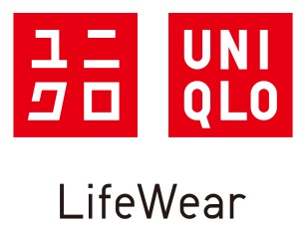
UNIQLO U 2018 Fall/Winter Collection to Launch Globally
from Friday, September 14
Wardrobe essentials feature vivid seasonal color palette and in-trend volumes XXXXXXXXXXXX

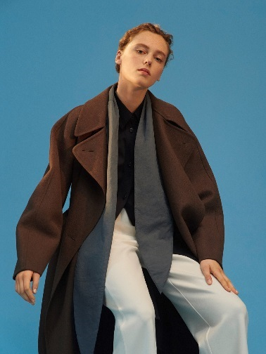
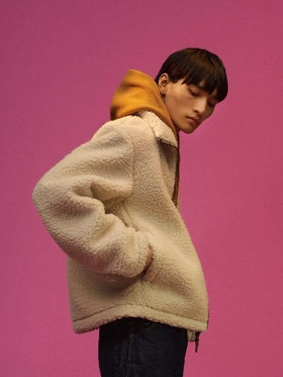
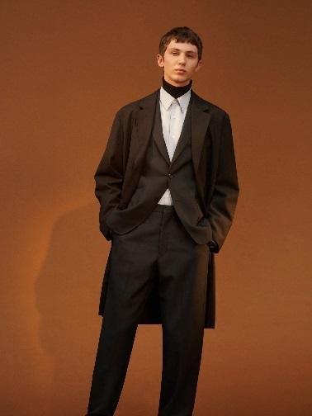
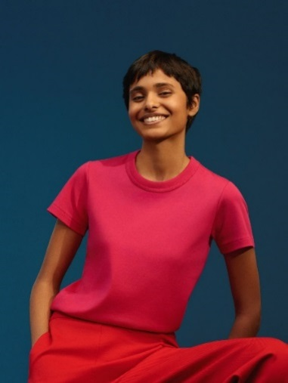
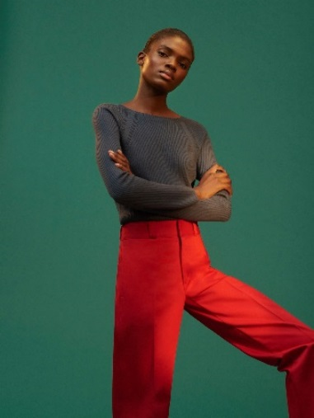
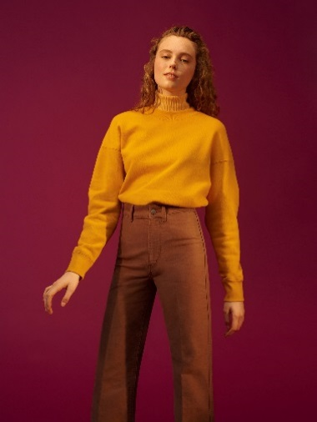
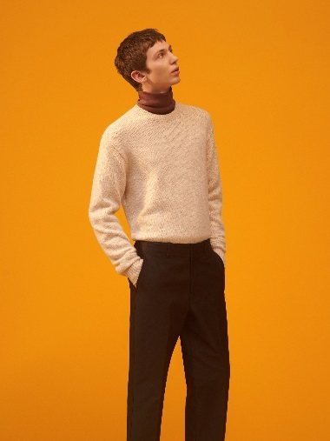
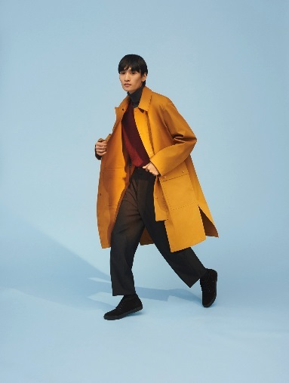

September 13, 2018, Bangkok – UNIQLO today announces that it will roll out the UNIQLO U 2018 Fall/Winter collection from Friday, September 14. The collection represents a commitment to reinventing basics as the future of LifeWear.

The Christophe Lemaire-led design team at the UNIQLO Paris R&D Center is constantly evolving its advanced ideas for the Uniqlo U designs, patterns, fabric development, and sewing techniques. Since the line’s debut two years ago, its mainstay items have become even more attractive, with its innovations transforming into contemporary essentials. The latest collection features a vivid fall and winter color palette and designs with in-trend volumes. It is elegantly timeless while showcasing diverse ideas that symbolize the future of LifeWear.

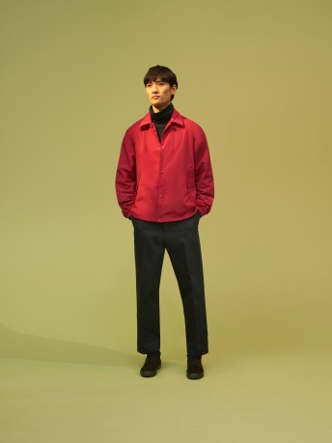
The collection features brilliant reds and fuchsias as rich and warm accents that symbolize the coming of fall. The styling for this season emphasizes volume through dolman sleeves for women’s fleece blousons and boxy silhouettes for men’s fleece jackets. Women’s items exude comfort and confidence, while men’s pieces convey unpretentious relaxation.

The range includes men’s and women’s BLOCKTECH coats that is water repellent and windproofed. Women’s coats wick away inside moisture and have snap-on hoods, with hem slits that enhance comfort when walking or seated. This season sees 3D knits employing advanced WHOLEGARMENT technology for beautiful silhouettes that are also comfortable. There are two dress and three sweater designs for women. A special spinning technique has resulted in raised looks and soft textures in mélange sweaters. There are also sweaters with vintage-style link knitting and items in comfortable ponte fabrics.

Uniqlo U 18FW is available from 14 September onwards at the selected UNIQLO stores and online store which customers can enjoy the shopping from 9.05am. For more information about Uniqlo U 18FW collection, please visit www.uniqlo.com/UniqloU

Paris R&D Center
The Paris R&D Center complements UNIQLO’s other research and development offices in Tokyo, Shanghai, New York, and Los Angeles. While functioning as product design centers that work collaboratively across the world, these offices also gather information on local fashion trends, lifestyles and new materials.

Profile of Christophe Lemaire
Christophe Lemaire has been designing his namesake collection since 1991 and has served as Artistic Director of Lacoste and Artistic Director of women’s ready-to-wear at Hermès. In 2015 he partnered with UNIQLO resulting in the UNIQLO AND LEMAIRE collaboration collections for Fall/Winter 2015 and Spring/Summer 2016. Christophe Lemaire was appointed Artistic Director of the UNIQLO Paris R&D Center in 2016, where he and his handpicked team of designers create the Uniqlo U collection.

#####

About UNIQLO LifeWear
Apparel that comes from the Japanese values of simplicity, quality and longevity. Designed to be of the time and for the time, LifeWear is made with such modern elegance that it becomes the building blocks of each individual’s style. A perfect shirt that is always being made more perfect. The simplest design hiding the most thoughtful and modern details. The best in fit and fabric made to be affordable and accessible to all. LifeWear is clothing that is constantly being innovated, bringing more warmth, more lightness, better design, and better comfort to people’s lives.

About UNIQLO and Fast Retailing
UNIQLO is a brand of Fast Retailing Co., Ltd., a leading global Japanese retail holding company that designs, manufactures and sells clothing under seven main brands: Comptoir des Cotonniers, GU, Helmut Lang, J Brand, Princesse tam.tam, Theory, and UNIQLO. With global sales of approximately 1.7864 trillion yen for the 2016 fiscal year ending August 31, 2016 (US $17.31 billion, calculated in yen using the end of August 2016 rate of $1 = 103.2 yen), Fast Retailing is one of the world’s largest apparel retail companies, and UNIQLO is Japan’s leading specialty retailer.

UNIQLO continues to open large-scale stores in some of the world's most important cities and locations, as part of its ongoing efforts to solidify its status as a truly global brand. Today the company has around 1,800 stores in 18 markets worldwide including Japan, Australia, Belgium, Canada, China, France, Germany, Hong Kong, Indonesia, Malaysia, Philippines, Russia, Singapore, South Korea, Taiwan, Thailand, U.K. and the U.S. In addition, Grameen UNIQLO, a social business established in Bangladesh in September 2010, currently operates several Grameen UNIQLO stores in Dhaka. UNIQLO manages an integrated business model under which it designs, manufactures, markets and sells high-quality, casual apparel. The company believes that truly great clothes should be supremely comfortable, feature universal designs, are of high quality and offer a superb fit to everyone who wears them.

With a corporate statement committed to changing clothes, changing conventional wisdom and change the world, Fast Retailing is dedicated to creating great clothing with new and unique value to enrich the lives of people everywhere. For more information about UNIQLO and Fast Retailing, please visit www.uniqlo.com and www.fastretailing.com.

For media queries, please contact Verve:
Aunyarat Wetchakij (Annie) 02-204-8227, 085-099-0091, email aunyarat.wetchakij@vervethailand.com
Thawanrath Navaratana (Dae) 085-227-2924 email thawanrath.navaratana@vervethailand.com

